 |   FOODABLE
Brief Description

Foodable is a digital platform designed to reduce food waste by connecting local restaurants and grocery stores with charities that can make use of surplus food. With three types of users - public, charity, and contributor - Foodable allows public users to see top contributors and donors, access profiles, and donate through QR codes.Charities can view participating grocery stores and restaurants, give likes, and request contributions from contributors. Contributors, such as grocery stores and restaurants, can accept requests from charities and access their profiles.Through this platform, be part of the solution to help those in need.

Beneficiaries
Charities: The platform connects charities with restaurants and grocery stores that have surplus food, allowing them to provide food to those in need.
Contributors (restaurants and grocery stores): By donating surplus food to charities, contributors can reduce food waste and make a positive impact in their local communities.
Public: The platform allows the public to view top contributors and donors, and donate to charities, contributing to the reduction of food waste and supporting those in need.

Principles
Reduce food waste: The primary goal of the Foodable platform is to reduce food waste by connecting restaurants and grocery stores with local charities that can make use of surplus food.
Feed those in need: Foodable`s aims to help provide food to those in need by connecting charities with surplus food from contributors.
Transparency: Foodable is transparent in its operation, with clear information provided about the charities, contributors, and donors involved.
User-centered design: Foodable is designed with the needs of its users in mind, ensuring that it is user-friendly and accessible to all.
Respect user privacy: Foodable will respect user privacy and ensure that user data is handled securely and confidentially.
Impact: Foodable is designed to have a positive impact on society, reducing food waste and helping to feed those in need
Results

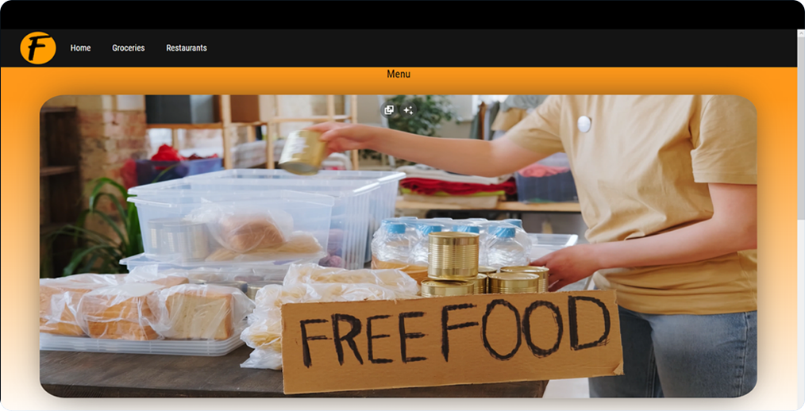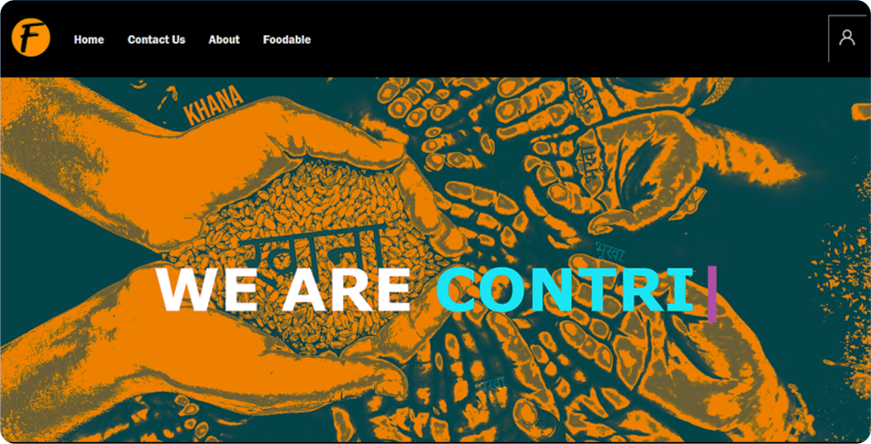

Department:- Team members:- Guide:-

Diploma in Computer 20C15004 Mayank Bisht Prof. Ami Shah
Science Engineering 20C11015 Nij Dave Prof. Yogita parmar
& Technology 20C11094 Dhyey Thanki Prof. Palak Bhatt

